**Street Food Vendor Locator**

Table of Contents

TITLE PAGE1

Table OF Contents2

CHAPTER3

1 INTRODUCTION3

2 BUISNESS REQUIREMENTS AND RU4

3 LIST OF FINAL ENTITIES and FINAL RELATIONS 5

4 ERD, TABLES, CLASS DIAGRAM 6

**Chapter 1**

## Introduction

Our Food Vendor Locator app makes it effortless to find and order from your favorite street food vendors. Browse through a curated list of vendors and place your order with ease. With features like vendor profiles, user reviews, and order tracking, you can make informed decisions and enjoy a hassle-free dining experience. Save your preferred vendors for quick access.

**Main Features:**

* User Profiles:

Vendors can create profiles for their stalls, including information such as stall name, location, reference points (landmarks), best dishes they offer, contact information (phone number), opening hours, and possibly a brief description.

Regular users can create profiles to access the app's features, such as leaving reviews and saving favorite stalls.

* Reviews and Ratings:

Users can leave reviews and ratings for the street food stalls they have visited. This feedback can help other users in deciding which stalls to visit. This will help in indexing of stalls according to their popularity.

* Search and Filter Options:

The app should include search and filter options to help users find street food stalls based on their preferences, such as cuisine type, location, price range, or ratings.

* Interactive Map:

Location of stalls can be seen by google maps integrated in the software.

## Chapter 2

## Business Requirements and Rules

**Business Requirements:**

* The administrator has exclusive access to manage user information and all app functionalities.
* Other users, such as vendors and customers, can manage products, transactions, and their own profiles.
* Vendors and customers are limited to performing few tasks only, such as adding new products or placing orders.
* Users and Vendors can create, delete, update, and display records.
* The app allows users to search for vendors and products.
* Transaction summaries are generated for each completed order, providing details such as items purchased and total cost.
* Access to the app is restricted to authorized users with unique usernames and passwords.
* The app enables easy tracking and updating of vendor and product records to ensure accuracy and relevance.
* The app interface prioritizes user-friendliness and interactivity, with intuitive navigation and clear prompts for actions like searching, ordering, and updating information.

**Business Rules:**

* All Primary Keys should be Unique.
* Primary Key or Component of a primary key attribute cannot be NULL.
* Foreign key value must match with the primary key of its home relation, or it may be completely Null.
* Date/Time must be by default.

## Chapter 3

## List of Final Entities

* User: Represents individuals who use the application. This entity could include attributes such as User ID, Username, Password, Email.
* Vendor: Represents street food vendors listed in the app. Attributes could include Vendor ID, Name, Location, Contact Information.
* Product: Represents the food items offered by vendors. Attributes might include Product ID, Name, Description, Price, Availability, and Vendor ID (to establish a relationship with the vendor).
* Invoice: Represents a completed transaction between a customer and a vendor. Attributes could include invoice ID, Date, Customer ID, Vendor ID, Product ID, Quantity, and Total Price.
* Feedback/Rating: Represents feedback provided by customers for vendors. Attributes might include Feedback ID, Customer ID, Vendor ID, Rating, and Comments.
* Favorite: Represents the list of favorite vendors saved by customers. This entity could establish a many-to-many relationship between users and vendors.

## List of Final Relationships

* A user can be associated with multiple vendors (if they are a customer) or none (if they are an admin). A vendor is associated with only one user.
* A vendor can offer multiple products. Each product belongs to only one vendor.
* A customer can order multiple products. Each product belongs to only one customer.
* A vendor can generate multiple invoices. Each bill is associated with only one Vendor.
* A product can be included in multiple orders, and an order can include multiple products.
* A customer can provide multiple feedback/ratings. Each feedback/rating is associated with only one customer.
* A vendor can receive multiple feedback/ratings. Each feedback/rating is associated with only one vendor.
* A user (customer) can have multiple favorite vendors, and a vendor can be favorited by multiple users. This relationship is represented by a junction table linking users and vendors.
* A customer can have multiple invoices. Each invoice is associated with only one customer.

## Chapter 4

## Entity Relationship Diagram:

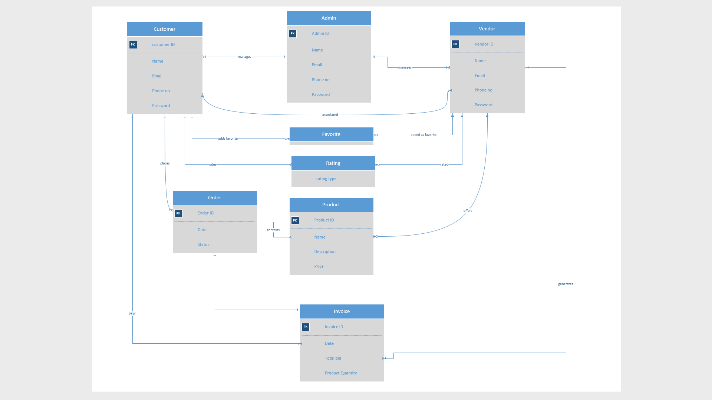

**T Admin**

## Tables with 3NF

|  |  |  |  |  |
| --- | --- | --- | --- | --- |
| **Admin id** | **name** | **email** | **phone** | **Password** |

**T_Vandor**

|  |  |  |  |  |
| --- | --- | --- | --- | --- |
| **Vendor id** | **name** | **Email** | **phone** | **password** |

**T_Customer**

|  |  |  |  |  |
| --- | --- | --- | --- | --- |
| **Customer id** | **CustName** | **Email** | **phone** | **password** |

**T_Product**

|  |  |  |  |  |
| --- | --- | --- | --- | --- |
| **ProductID** | **Name** | **Discription** | **Price** | **Vendor_ID** |

**T_order**

|  |  |  |  |  |  |
| --- | --- | --- | --- | --- | --- |
| **Order id** | **date** | **status** | **Vendor id** | **Product id** | **Customer id** |

**T_invoice**

|  |  |  |  |  |  |
| --- | --- | --- | --- | --- | --- |
| **Invoice id** | **total** | **quantity** | **Customer id** | **Order id** | **Vendor id** |

**T_rating**

|  |  |
| --- | --- |
| **code** | **rating** |

**T_favorite**

|  |  |
| --- | --- |
| **Customer id** | **Vendor id** |

**T_feedback**

|  |  |  |
| --- | --- | --- |
| **code** | **Customer id** | **Vendor id** |

* **Class Diagram**

